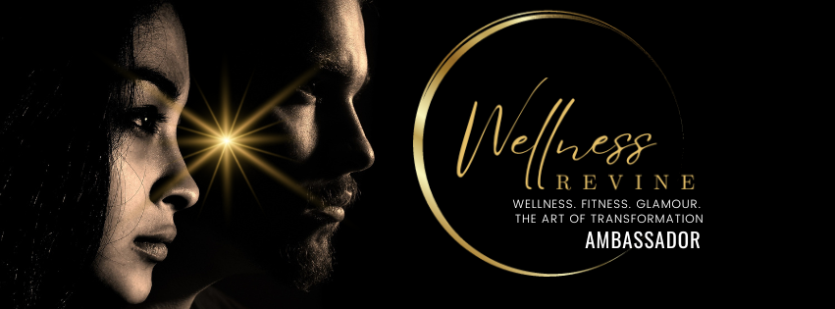

**Registration Form**

Welcome to the Wellness Revive Ambassador Program!

Please complete the following registration form to become an ambassador for promoting wellness, fitness, glamour, and transformation.

**Personal Information:**

Name: _______________________________Surname_________________________

Address: ______________________________________________________________

Email:______________________________Contact number: _____________________

Date of birth_____________________Present citizenship _______________________

**Emergency Contact Information**:

Full Name _____________________________

Relationship: ___________________________

Phone Number: _________________________

Page 1

**Social Media Information:**

Instagram : _______________________________

Facebook : _______________________________

Twitter : _______________________________

TikTok : _______________________________

Blog/Website (if any): _______________________________

Other Social Media: _______________________________

**Experience and Interests:**

Have you previously worked as a brand ambassador?

  Yes [ ] No [ ]

If yes, please provide details (e.g., brand names, duration, roles)

  ______________________________________________________

  ______________________________________________________

Why do you want to become a Wellness Revive Ambassador?

  ______________________________________________________

  ______________________________________________________

What aspects of wellness, fitness, glamour, and transformation are you most passionate about?

  ______________________________________________________

  ______________________________________________________

Please provide links to any relevant content or posts that showcase your interest and experience in these areas:

  ______________________________________________________

  ______________________________________________________

Availability:

Are you available to participate in events, workshops or photoshoots?

  Yes [ ] No [ ]

How many hours per week can you dedicate to being a Wellness Revive Ambassador?

  ______________________________________________________

Page 2

Additional Information:

Do you have any specific skills or talents that you think would be beneficial for your role as an ambassador?

  ______________________________________________________

  ______________________________________________________

Do you have any dietary restrictions or health conditions we should be aware of?

  ______________________________________________________

  ______________________________________________________

Once the application is approved, are you willing to pay the non-refundable & non-transferrable?

Registration Fee NZD 499.00 including the workshop below

The amount to pay and Bank Account details will be provided to you on the Letter of

Acceptance.

The fee covers

3 Months workshop, training and Social. Except Graduation & Celebration NOT included.

|  |
| --- |
| **Pre Social** |
| 16/11/2024 Sat 12pm -1.30pm Wellness Revive Launch Fable Hotel 58 Queen St |
| 30/11/2024 Sat 6pm to 10pm Meet & Greet Christmas Party CS Fitness |
|  |
| **Workshops** |
| 1/2/2025 Sat 2pm to 5pm Introduction/walk with posture CS Fitness |
| 15/2/2025 Sat 2pm to 5pm Hair & makeup/skin care CS Fitness |
| 1/3/2025 Sat 2pm to 5pm Fitness/Nutrition/walk with posture CS Fitness |
| 15/3/2025 Sat 2pm to 5pm Public speaking /Social media CS Fitness |
| 29/3/2025 Sat 2pm to 5pm Fashion and style /walk with posture CS Fitness |
| 5 /4/2025 Sat 2pm to 5pm Body and mind/walk with posture CS Fitness |
| 12/4/2025 Sat TBC **Graduation & Celebration** Venue TBC |

**\*\*\*30 min Break with 5min Cooking class in every workshop**

page 3

Please Attach your latest Digital Photo of 1 full body and I head shot

**Agreement:**

By signing below, you agree to abide by the terms and conditions outlined in the Wellness Revive Ambassador Contract. You confirm that the information provided in this form is accurate to the best of your knowledge.

Signature: _______________________Date:_______________________________

Thank you for your interest in becoming a Wellness Revive Ambassador! We will review your application and get in touch with you soon.

**For Office Use Only:**

Application Received By: ______________________________

Date: ______________________________________________

Approved By: _______________________________________

Date: ______________________________________________

Notes: _____________________________________________

  __________________________________________________

Wellness Revive Ambassador by Candi Soo Fitness Ltd

D9, 18 Oteha Valley Road Extension, Albany 0632, Auckland

Phone: 0226870737

Email:info@candisoo.co.nz

Please submit this form to [info@candisoo.co.nz](mailto:info@candisoo.co.nz) or mail it to D9,18 Oteha Valley Road Extension, Albany 0632, Auckland

Page 4

